WEEK 5

Name of School: ……………………………………………………………………………….……..
Name of Teacher: ……………………………………………………………………………………
Date: |  | Day: MONDAY |  |  | Strand: VALUES AND BELIEFS
 |  |  |  |  | Sub Strand: OUR BELIEFS
Class: KG 1 |  |  | Class Size:
Content Standard:  K1.3.4.1 Demonstrate understanding of and relating well with people with different beliefs |  |  |  | Indicator:  K1.3.4.1.1 Talk about God as the Creator of all things and discuss different ways that people worship him.  K1.3.4.1.5 Play different musical instrument, sing religious songs and dance on the music.
Performance Indicator:  - Learners can talk about God as the Creator of all things and discuss different ways that people worship him.  - Learners can play different musical instrument, sing religious songs and dance on the music |  |  |  |  | Core Competencies:  Communication and collaboration, Critical thinking, Personal Development and Leadership
Phase/Duration | Learners Activities |  |  |  |  | Resources
PHASE 1: STARTER | Let learners sing a song in relation to the lesson.  RCA QUESTION  1. Did you enjoy the song?  2. What words did you hear in the song?
PHASE 2: NEW LEARNING  CIRCLE TIME | Engage learners in the community circle time.  ANIMAL WALK  Your child will have fun walking just like the animals!  Help him use his imagination to move his arms, legs, head, and body.  Leaf through various picture books about animals.  As you read, encourage your kids to walk like the animals in the books.  Help them by describing and demonstrating if necessary. For instance, show them how the duck waddles, the crab moves sideways, the kangaroo leaps, the elephant lumbers, the worm inches, etc. |  |  |  |  | picture books
GROUP ACTIVITY 1  (OUTDOOR) | Using the KWL strategy, introduce the theme for the week and assist learners to learn more about different beliefs system of their friends.  K- Call on the learners to share what they know about God and what religious group they belong to.  Learners should also mention the different  ways they refer to God in their religious groups.  W- Allow learners to ask question about what they want to know from their friends about how they worship.  Learners talk about and dramatize how they worship, pray and the songs they sing.  L- Encourage learners to appreciate each other and then share what they have learned (L) from their friends.  Decorate the classroom with conversational posters of different religious groups and have learners use them as resource to talk about their beliefs.  Assessment: Call learners in turns to demonstrate some modes of worship they know (dancing, drumming, singing, praying, kneeling etc.) |  |  |  |  | Big book, word card and sentence card, pictures and videos
PHONICS | Engage learners to sing songs and recite some familiar rhymes that relates to the target sound.  Guide learners to pronounce and write the target sound in the sand tray or exercise books.  Have learners say three or four words that contain the target sound.  Using flash cards, learners read words that contain the target sound.  RCA QUESTIONS  1. What sound have we learnt today?  2. What other letter sound do you know?  3. Mention any object in the classroom or home that begins with the target letter sound. |  |  |  |  | Word cards, letter cards.
GROUP ACTIVITY 2  (INDOOR) | Using different religious songs and musical instruments, have learners be in groups and perform and dance to the music of the three different religions in Ghana.  Encourage learners to sing and dance together as a way of appreciating each other.  Have learners discuss their performances.  Create different everyday situations and scaffold learners to add numbers.  E.g. Combine amount of money collected at church service, etc. Extend this activity with other objects.  Using level-appropriate sight words, display sight words on cards and guide learners to read.  Explain the words and guide learners to use the words to form short and simple sentences.  Let learners copy words in their exercise book.  Have learners to read the sight words on the chart in turns.  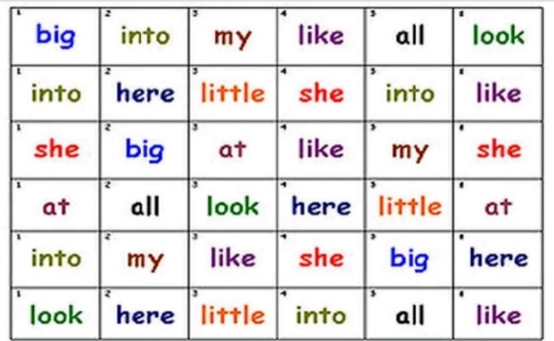  Engage learners to play the “Label the school” game.  Walk around each room of the school with your child. As she names the school items, use a permanent marker to write the names on index cards or sentence strips. Attach them to the item with tape.  Each time kids sits on, opens, sleeps in, or uses one of the items, draw their attention to the card and ask them to read it.  To make the game a little more interesting, you can even ask them to use the word in a sentence, such as, “This is madam’s chair and I am not supposed to sit in it,” or “ I like to write on the blackboard”.
LEARNING CENTER | Engage learners to play freely at the learning centers.  Join in and ask learners questions frequently to guide their play. |  |  |  |  | Learning center
STORY SHARING | Tell learners a story.  Pause regularly and ask questions to make sure learners are following.  RCA QUESTION  1. Was the story interesting?  2. What part of the story did you like?  3. what have you learnt from the story? |  |  |  |  | Word cards, letter cards.
PHASE 3: REFLECTION | Learners share what they have learnt with their peers.  Give learners homework to do at home

Date: |  | Day: TUESDAY |  |  | Strand: VALUES AND BELIEFS
 |  |  |  |  | Sub Strand: OUR BELIEFS
Class: KG 1 |  |  | Class Size:
Content Standard:  K1.3.4.1 Demonstrate understanding of and relating well with people with different beliefs |  |  |  | Indicator:  K1.3.4.1.2 Handle their religious scriptures (book) appropriately.  K1.3.4.1.4 Draw one activity that we do when worshipping God and label it with one or two words
Performance Indicator:  - Learners can handle their religious scriptures (book) appropriately.  - Learners can draw one activity that we do when worshipping God and label it with one or two words |  |  |  |  | Core Competencies:  Communication and collaboration, Critical thinking, Personal Development and Leadership
Phase/Duration | Learners Activities |  |  |  |  | Resources
PHASE 1: STARTER | Let learners sing a song in relation to the lesson.  RCA QUESTION  1. Did you enjoy the song?  2. What words did you hear in the song?
PHASE 2: NEW LEARNING  CIRCLE TIME | Engage learners in the community circle time.  BACK WORDS.  Put learners into groups to play the backward game.  Start with simple sentences like “More milk please” and “Thank you.”  Say them backwards: “Please milk more” and“ You thank.”  Demonstrate a few times so she understands how to play.  Progress to longer sentences as your kids get better at playing the game. |  |  |  |  | flashcards
GROUP ACTIVITY 1  (OUTDOOR) | Display different scriptures, the Bible, Learners Bible stories, the Quran and any others that the learners could bring.  Using the learners’ book as the model, scaffold learners to identify how to open the books paying attention to the page numbers in the books.  Use a short story to assist learners appreciate and respect other religious books.  Have learners either sing or draw one object each that identify the three main religions in Ghana and talk about it.  Let learners represent the number of the main religions with model numbers  Group learners according to the religion they belong to.  Write a short but simple bible quotes for learners to memorize.  Example:  John 10:30 “I and my father are one”  John 11:35 “And Jesus wept”  Genesis 1:1 “In the beginning God created the Heavens and the Earth”  Teach learners new action songs and let them sing and dance as well.  I AM A CHRISTIAN  I am a C  I am a CH  I am a CHRISTIAN  And I am CHRISTIAN in my heart.  And I will LIVE forever  Assessment: Learners in turns and in groups sing and recite simple Bible quotations learnt.
PHONICS | Engage learners to sing songs and recite some familiar rhymes that relates to the target sound.  Guide learners to pronounce and write the target sound in the sand tray or exercise books.  Have learners say three or four words that contain the target sound.  Using flash cards, learners read words that contain the target sound.  RCA QUESTIONS  1. What sound have we learnt today?  2. What other letter sound do you know?  3. Mention any object in the classroom or home that begins with the target letter sound. |  |  |  |  | Word cards, letter cards.
GROUP ACTIVITY 2  (INDOOR) | Using poster and picture depicting the three main religion at worship, discuss the three main religion with the learners.  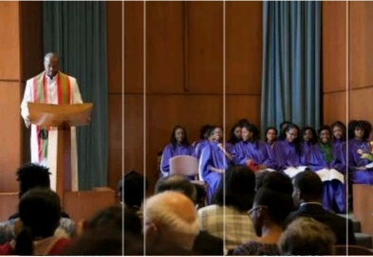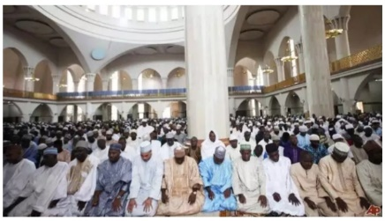  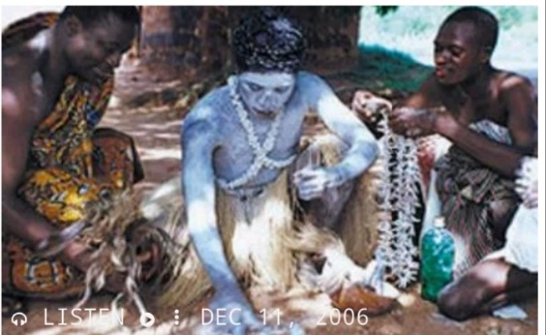  Providing learners with sheet of paper or exercise books, have learners draw, paint and label one way to worship God and label it.  Teacher provides different vocabulary on the whiteboard as a resource.  Learners decorate the classroom with their pictures.  Have learners sort the drawings according to the given criterion (e.g. religion, colors, size) and match the groups with number cards.  You can have learners replicate the matching activity into their exercise books  Assessment: Learners to draw one activity that we do when worshipping God and label it with one or two words.
LEARNING CENTER | Engage learners to play freely at the learning centers.  Join in and ask learners questions frequently to guide their play. |  |  |  |  | Learning center
STORY SHARING | Tell learners a story.  Pause regularly and ask questions to make sure learners are following.  RCA QUESTION  1. Was the story interesting?  2. What part of the story did you like?  2. Retell the story to your partner.  4. what have you learnt from the story? |  |  |  |  | Word cards, letter cards.
PHASE 3: REFLECTION | Learners share what they have learnt with their peers.  Give learners homework to do at home

Date: |  | Day: WEDNESDAY |  |  | Strand: VALUES AND BELIEFS
 |  |  |  |  | Sub Strand: OUR BELIEFS
Class: KG 1 |  |  | Class Size:
Content Standard:  K1.3.4.1 Demonstrate understanding of and relating well with people with different beliefs |  |  |  | Indicator:  K1.3.4.1.3 Interact actively with peers during a teacher-read aloud session about religious beliefs.  K1.3.4.1.4 Draw one activity that we do when worshipping God and label it with one or two words
Performance Indicator:  - Learners can interact actively with peers during a teacher-read aloud session about religious beliefs,  - Learners can draw one activity that we do when worshipping God and label it with one or two words |  |  |  |  | Core Competencies:  Communication and collaboration, Critical thinking, Personal Development and Leadership
Phase/Duration | Learners Activities |  |  |  |  | Resources
PHASE 1: STARTER | Let learners sing a song in relation to the lesson.  RCA QUESTION  1. Did you enjoy the song?  2. What words did you hear in the song?
PHASE 2: NEW LEARNING  CIRCLE TIME | Engage learners in the community circle time.  Read a book about cars and trucks together and study the pictures.  Cut the top and bottom off a large box, leaving the sides intact.  Guide learners to decorate the outside of the box to look like a car or truck using felt pens, stickers, etc.  When the car is finished, let your kids take a drive around the classroom.  For added fun, set up roads by laying down rope as a guide, and set up stop signs along the route.  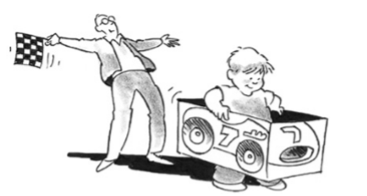 |  |  |  |  | large box, felt pens, stickers
GROUP ACTIVITY 1  (OUTDOOR) | Follow the “before reading, during reading and after reading” strategies as you read an informational text on different religious groups in Ghana and how they worship.  Pause often and have the learners respond to the text by relating the information to their lives.  Use visual information such as pictures to explain unfamiliar words such as mosque, chapel, and shrine  Learners identify and share what they have learnt about the things that we all do in common and things that are different about the three religious  groups.  Allow learners to talk a lot using the new vocabulary that they have heard from the book.  Learners role play what their religious leaders do  when leading worship.  Have learners talk about and demonstrate how they will relate with their classmates and other learners in harmony although they belong to different religious groups.  Count the letters in at least two religious books and/or name of worship place and use comparative language (“more than”, “less than”, “same as”) and signs ([<], [>], [=]) to describe the letters in the spelling of the religious books  e.g. Bible has 5 letters and chapel has 6.  The number of letters in chapel is more the letters in Bible. Bible < Chapel  Quran has 5 letters and Mosque has 6.  The number of letters in Mosque is more the letters in Quran. Quran < Mosque  Mosque has 6 letters and Shrine has 6.  The number of letters in Mosque is the same as the letters in Shrine. Mosque = Shrine  You can extend this activity using different  objects.  Assessment: Learners role play what their religious leaders do when leading worship. |  |  |  |  | Poster/ cut out pictures, Cut out shapes, big books, counters, crayons, word cards and number cards
PHONICS | Engage learners to sing songs and recite some familiar rhymes that relates to the target sound.  Guide learners to pronounce and write the target sound in the sand tray or exercise books.  Have learners say three or four words that contain the target sound.  Using flash cards, learners read words that contain the target sound.  RCA QUESTIONS  1. What sound have we learnt today?  2. What other letter sound do you know?  3. Mention any object in the classroom or home that begins with the target letter sound. |  |  |  |  | Word cards, letter cards.
GROUP ACTIVITY 2  (INDOOR) | Using poster and picture depicting the three main religion at worship, discuss the three main with the learners.  Providing learners with sheet of paper or exercise books, have learners draw, paint and label one way to worship God and label it.  Teacher provides different vocabulary on the whiteboard as a resource.  Learners decorate the classroom with their pictures.  Have learners sort the drawings according to the given criterion (e.g. religion, colors, size) and match the groups with number cards.  You can have learners replicate the matching activity into their exercise books  Assessment: Learners to draw one activity that we do when worshipping God and label it with one or two words.
LEARNING CENTER | Engage learners to play freely at the learning centers.  Join in and ask learners questions frequently to guide their play. |  |  |  |  | Learning center
STORY SHARING | Tell learners a story.  Pause regularly and ask questions to make sure learners are following.  RCA QUESTION  1. Was the story interesting?  2. What part of the story did you like?  2. Retell the story to your partner.  4. what have you learnt from the story? |  |  |  |  | Word cards, letter cards.
PHASE 3: REFLECTION | Learners share what they have learnt with their peers.  Give learners homework to do at home

Date: |  | Day: THURSDAY |  |  | Strand: VALUES AND BELIEFS
 |  |  |  |  | Sub Strand: OUR BELIEFS
Class: KG 1 |  |  | Class Size:
Content Standard:  K1.3.4.1 Demonstrate understanding of and relating well with people with different beliefs |  |  |  | Indicator:  K1.3.4.1.3 Use visual information to  understand the unfamiliar words when reading and use new  vocabulary acquired to talk about their beliefs  K1.3.4.1.4 Draw one activity that we do when worshipping God and label it with one or two words
Performance Indicator:  - Learners can draw one activity that we do when worshipping God and label it with one or two words  - Learners can use visual information to  understand the unfamiliar words when reading and use new  vocabulary acquired to talk about their beliefs |  |  |  |  | Core Competencies:  Communication and collaboration, Critical thinking, Personal Development and Leadership
Phase/Duration | Learners Activities |  |  |  |  | Resources
PHASE 1: STARTER | Let learners sing a song in relation to the lesson.  RCA QUESTION  1. Did you enjoy the song?  2. What words did you hear in the song?
PHASE 2: NEW LEARNING  CIRCLE TIME | Engage learners in the community circle time and play the “Can you guess” game.  Select an interesting and easily visible item located in the room.  Tell your kids you are thinking about something in the room and give them clues such as color, size, or shape.  Have them try to guess the item.  If they guess incorrectly, give them another clue and let them guess again.  Continue as they guess correct.
GROUP ACTIVITY 1  (OUTDOOR) | Using poster and picture depicting the three main religion at worship, discuss the three main with the learners.  Providing learners with sheet of paper or exercise books, have learners draw, paint and label one way to worship God and label it.  Teacher provides different vocabulary on the  whiteboard as a resource.  Learners decorate the classroom with their pictures.  Have learners sort the drawings according to the given criterion (e.g. religion, colors, size) and match the groups with number cards.  You can have learners replicate the matching activity into their exercise books  Learners sing rhymes and dance with actions  Assessment: Learners to draw one activity that we do when worshipping God and label it with one or two words. |  |  |  |  | Poster/ cut out pictures, Cut out shapes, big books, counters, crayons, word cards and number cards
PHONICS | Engage learners to sing songs and recite some familiar rhymes that relates to the target sound.  Guide learners to pronounce and write the target sound in the sand tray or exercise books.  Have learners say three or four words that contain the target sound.  Using flash cards, learners read words that contain the target sound.  RCA QUESTIONS  1. What sound have we learnt today?  2. What other letter sound do you know?  3. Mention any object in the classroom or home that begins with the target letter sound. |  |  |  |  | Word cards, letter cards.
GROUP ACTIVITY 2  (INDOOR) | Follow the “before reading, during reading and after reading” strategies as you read an informational text on different religious groups in Ghana and how they worship.  Pause often and have the learners respond to the text by relating the information to their lives.  Use visual information such as pictures to explain unfamiliar words such as mosque, chapel, and shrine  Learners identify and share what they have learnt about the things that we all do in common and things that are different about the three religious  groups.  Allow learners to talk a lot using the new vocabulary that they have heard from the book.  Learners role play what their religious leaders do  when leading worship.  Have learners talk about and demonstrate how they will relate with their classmates and other learners in harmony although they belong to different religious groups.  Count the letters in at least two religious books and/or name of worship place and use comparative language (“more than”, “less than”, “same as”) and signs ([<], [>], [=]) to describe the letters in the spelling of the religious books  e.g. Bible has 5 letters and chapel has 6.  The number of letters in chapel is more the letters in Bible. Bible < Chapel  Quran has 5 letters and Mosque has 6.  The number of letters in Mosque is more the letters in Quran. Quran < Mosque  Mosque has 6 letters and Shrine has 6.  The number of letters in Mosque is the same as the letters in Shrine. Mosque = Shrine  You can extend this activity using different objects.  Teach, sing songs and recite rhymes in relation to the lesson.  Learners to sing the songs, recite rhymes and dance with actions.  Assessment: Learners role play what their religious leaders do when leading worship.
LEARNING CENTER | Engage learners to play freely at the learning centers.  Join in and ask learners questions frequently to guide their play. |  |  |  |  | Learning center
STORY SHARING | Tell learners a story.  Pause regularly and ask questions to make sure learners are following.  RCA QUESTION  1. Was the story interesting?  2. What part of the story did you like?  2. Retell the story to your partner.  4. what have you learnt from the story? |  |  |  |  | Word cards, letter cards.
PHASE 3: REFLECTION | Learners share what they have learnt with their peers.  Give learners homework to do at home

Date: |  | Day: FRIDAY |  |  | Strand: VALUES AND BELIEFS
 |  |  |  |  | Sub Strand: OUR BELIEFS
Class: KG 1 |  |  | Class Size:
Content Standard:  K1.3.4.1 Demonstrate understanding of and relating well with people with different beliefs |  |  |  | Indicator:  K1.3.4.1.1 Talk about God as the Creator of all things and discuss different ways that people worship him  K1.3.4.1.5 Play different musical instrument, sing religious songs and dance on the music.
Performance Indicator:  - Learners can play different musical instrument, sing religious songs and dance on the music.  - Learners can talk about God as the Creator of all things and discuss different ways that people worship him |  |  |  |  | Core Competencies:  Communication and collaboration, Critical thinking, Personal Development and Leadership
Phase/Duration | Learners Activities |  |  |  |  | Resources
PHASE 1: STARTER | Engage learners to sing songs and recite a few rhymes they are familiar with  I HAVE A VERY BIG GOD  I have a very big God oo,  He is always by my side.  A very God oo,  By my side, by my side
PHASE 2: NEW LEARNING  CIRCLE TIME | Engage learners in the community circle time.  Sit the children in a circle, facing inwards.  One child is chosen to be “it”. it walks around the circle, gently tapping each other player in turn on the head or shoulder, naming each player as a ‘Duck’. When ready, it chooses one player to be the ‘Goose’ – tapping that player on the head and shout ‘Goose’.  The player selected as Goose stands up and chase It around the circle, trying to tap her before she gets all the way around the circle to sit back in the spot where the Goose was originally sitting.  If the Goose is not able to tag the It, then Goose becomes It and the game continues.
GROUP ACTIVITY 1  (OUTDOOR) | Using different religious songs and musical instruments, have learners be in groups and perform and dance to the music of the three different religions in Ghana.  Encourage learners to sing and dance together as a way of appreciating each other.  Have learners discuss their performances.  Create different everyday situations and scaffold learners to add numbers.  E.g. Combine amount of money collected at church service, etc. Extend this activity with other objects.  Using level-appropriate sight words, display sight words on cards and guide learners to read.  Explain the words and guide learners to use the words to form short and simple sentences.  Have learners copy words into their exercise books.  Assessment: Have learners to read the sight words on the chart in turns. |  |  |  |  | Poster/ cut out pictures, Cut out shapes, big books, counters, crayons, word cards and number cards
PHONICS | Engage learners to sing songs and recite some familiar rhymes that relates to the target sound.  Guide learners to pronounce and write the target sound in the sand tray or exercise books.  Have learners say three or four words that contain the target sound.  Using flash cards, learners read words that contain the target sound.  RCA QUESTIONS  1. What sound have we learnt today?  2. What other letter sound do you know?  3. Mention any object in the classroom or home that begins with the target letter sound. |  |  |  |  | Word cards, letter cards.
GROUP ACTIVITY 2  (INDOOR) | Using the KWL strategy, introduce the theme for the week and assist learners to learn more about different beliefs system of their friends.  K- Call on the learners to share what they know about God and what religious group they belong to.  Learners should also mention the different  ways they refer to God in their religious groups.  W- Allow learners to ask question about what they want to know from their friends about how they worship.  Learners talk about and dramatize how they worship, pray and the songs they sing.  L- Encourage learners to appreciate each other and then share what they have learned (L) from their friends.  Decorate the classroom with conversational posters of different religious groups and have learners use them as resource to talk about their beliefs.  Assessment: Call learners in turns to demonstrate some modes of worship they know (dancing, drumming, singing, praying, kneeling etc.)
LEARNING CENTER | Engage learners to play freely at the learning centers.  Join in and ask learners questions frequently to guide their play. |  |  |  |  | Learning center
STORY SHARING | Tell learners a story.  Pause regularly and ask questions to make sure learners are following.  RCA QUESTION  1. Was the story interesting?  2. What part of the story did you like?  2. Retell the story to your partner.  4. What have you learnt from the story? |  |  |  |  | Word cards, letter cards.
PHASE 3: REFLECTION | Learners share what they have learnt with their peers.  Give learners homework to do at home.

Vetted by: ……………………………. Sign: ……………………… Date: ……………………..

